'Programmer: Samantha Naini
'Exercise: 4-2-42 (exam)
'Date: 3/29/2012
'Program Purpose: Find best bank by calculating API.

Option Strict On
Option Explicit On

Public Class frmCompareIntRates

Private Sub btnCompute_Click(ByVal sender As System.Object, ByVal e As System.EventArgs) Handles btnCompute.Click

Dim Rate1, Rate2, NumPeriod1, NumPeriod2, APYOne, APYTwo As Double
Dim BestBank As String

Rate1 = CDbl(txtRate1.Text) / 100
Rate2 = CDbl(txtRate2.Text) / 100

NumPeriod1 = CDbl(txtPeriod1.Text)
NumPeriod2 = CDbl(txtPeriod2.Text)

BestBank = CStr(txtBestBank.Text)

APYOne = (1 + (Rate1 / NumPeriod1)) ^ NumPeriod1 - 1

APYTwo = (1 + (Rate2 / NumPeriod2)) ^ NumPeriod2 - 1

If APYOne > APYTwo Then
txtBestBank.Text = " Bank 1 "
Else
txtBestBank.Text = " Bank 2 "
End If

txtAPY1.Text = FormatPercent(APYOne, 3)
txtAPY2.Text = FormatPercent(APYTwo, 3)
End Sub

Private Sub btnClear_Click(ByVal sender As System.Object, ByVal e As System.EventArgs) Handles btnClear.Click
txtAPY1.Clear()
txtAPY2.Clear()
txtPeriod1.Clear()
txtPeriod2.Clear()
txtRate1.Clear()
txtRate2.Clear()
txtRate1.Focus()
End Sub

Private Sub btnEnd_Click(ByVal sender As System.Object, ByVal e As System.EventArgs) Handles btnEnd.Click
Me.Close()
End Sub
End Class
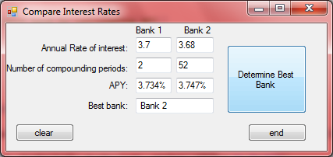
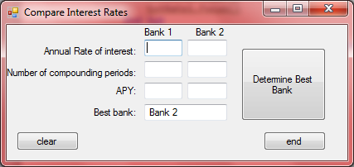←clear button

